**Task 4- Spring Core – Load Country from Spring Configuration XML**

1-Project Structure

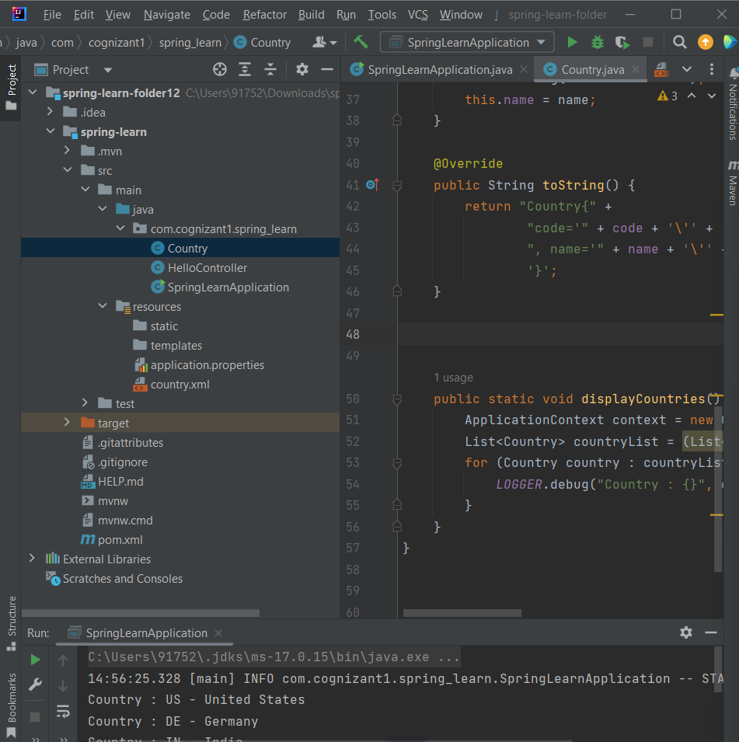

1. SpringLearnApplication.java

package com.cognizant1.spring_learn;  
  
import com.cognizant1.spring_learn.Country;  
  
import org.slf4j.Logger;  
import org.slf4j.LoggerFactory;  
import org.springframework.context.ApplicationContext;  
import org.springframework.context.support.ClassPathXmlApplicationContext;  
  
import java.util.List;  
  
import static com.cognizant1.spring_learn.Country.*displayCountries*;  
  
public class SpringLearnApplication {  
  
 private static final Logger *LOGGER* = LoggerFactory.*getLogger*(SpringLearnApplication.class);  
  
 public static void main(String[] args) {  
 *LOGGER*.info("STARTING THE APPLICATION");  
  
 *displayCountry*();  
 *displayCountries*();  
  
 *LOGGER*.info("APPLICATION FINISHED");  
 }  
  
 private static void displayCountry() {  
 }  
  
 public static void displayCountries() {  
 ApplicationContext context = new ClassPathXmlApplicationContext("country.xml");  
 List<Country> countryList = (List<Country>) context.getBean("countryList");  
  
 // This will print to console  
 for (Country country : countryList) {  
 System.*out*.println("Country : " + country.getCode() + " - " + country.getName());  
 }  
 }  
}

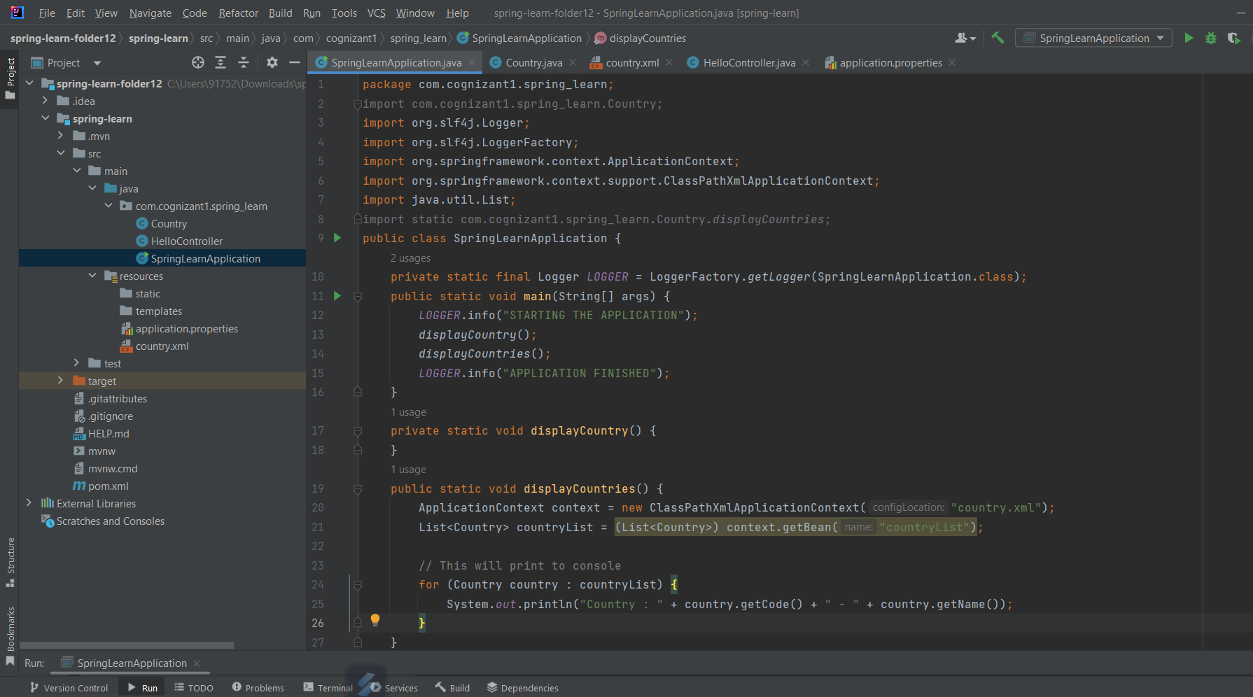

1. Country.java
2. package com.cognizant1.spring_learn;  
     
   import org.slf4j.Logger;  
   import org.slf4j.LoggerFactory;  
   import org.springframework.context.ApplicationContext;  
   import org.springframework.context.support.ClassPathXmlApplicationContext;  
     
   import java.util.List;  
     
   public class Country {  
    private static final Logger *LOGGER* = LoggerFactory.*getLogger*(Country.class);  
     
    private String code;  
    private String name;  
     
    public Country() {  
    *LOGGER*.debug("Inside Country Constructor.");  
    }  
     
    public String getCode() {  
    *LOGGER*.debug("Inside getCode");  
    return code;  
    }  
     
    public void setCode(String code) {  
    *LOGGER*.debug("Inside setCode");  
    this.code = code;  
    }  
     
    public String getName() {  
    *LOGGER*.debug("Inside getName");  
    return name;  
    }  
     
    public void setName(String name) {  
    *LOGGER*.debug("Inside setName");  
    this.name = name;  
    }  
     
    @Override  
    public String toString() {  
    return "Country{" +  
    "code='" + code + '\'' +  
    ", name='" + name + '\'' +  
    '}';  
    }  
     
     
     
    public static void displayCountries() {  
    ApplicationContext context = new ClassPathXmlApplicationContext("country.xml");  
    List<Country> countryList = (List<Country>) context.getBean("countryList");  
    for (Country country : countryList) {  
    *LOGGER*.debug("Country : {}", country);  
    }  
    }  
   }
3. country.xml
4. package com.cognizant1.spring_learn;  
     
   import org.slf4j.Logger;  
   import org.slf4j.LoggerFactory;  
   import org.springframework.context.ApplicationContext;  
   import org.springframework.context.support.ClassPathXmlApplicationContext;  
     
   import java.util.List;  
     
   public class Country {  
    private static final Logger *LOGGER* = LoggerFactory.*getLogger*(Country.class);  
     
    private String code;  
    private String name;  
     
    public Country() {  
    *LOGGER*.debug("Inside Country Constructor.");  
    }  
     
    public String getCode() {  
    *LOGGER*.debug("Inside getCode");  
    return code;  
    }  
     
    public void setCode(String code) {  
    *LOGGER*.debug("Inside setCode");  
    this.code = code;  
    }  
     
    public String getName() {  
    *LOGGER*.debug("Inside getName");  
    return name;  
    }  
     
    public void setName(String name) {  
    *LOGGER*.debug("Inside setName");  
    this.name = name;  
    }  
     
    @Override  
    public String toString() {  
    return "Country{" +  
    "code='" + code + '\'' +  
    ", name='" + name + '\'' +  
    '}';  
    }  
     
     
     
    public static void displayCountries() {  
    ApplicationContext context = new ClassPathXmlApplicationContext("country.xml");  
    List<Country> countryList = (List<Country>) context.getBean("countryList");  
    for (Country country : countryList) {  
    *LOGGER*.debug("Country : {}", country);  
    }  
    }  
   }
5. Output

